**Walk 46 Ballingham**

Last walked in December 2016

**Description.** An 8km(5 mile) moderate ramble with a steep descent. Sloping fields, view from Carey Bank and along Wye Riverbank. (This is an edited version of a walk in the Hereford Times in July).

**Start.**  Car park at Ballington Village Hall. Explorer map 189 5316 Grid 57,

**Directions from Belmont roundabout** (turn milometer to zero). Take the A49 to Ross-on-Wye. At the first set of traffic lights, after 1/3 of a mile, you TL and head for Holme Lacy. When you get to Holme Lacy, and at 4.4 miles you TR for Holm Lacy House and continue on to Ballingham. At 5.9 miles you TL, signed Ballingham. At 7.8 miles TL to the village hall and after another 50 metres TL into the car park.

**1. Ballingham Village Hall. *Ballingham is a small*** [***village***](http://en.wikipedia.org/wiki/Village) ***of about 140 people situated in a loop of the*** [***River Wye***](http://en.wikipedia.org/wiki/River_Wye)***, between*** [***Hereford***](http://en.wikipedia.org/wiki/Hereford) ***and*** [***Ross-on-Wye***](http://en.wikipedia.org/wiki/Ross-on-Wye)***. It has a*** [***parish***](http://en.wikipedia.org/wiki/Parish)[***church***](http://en.wikipedia.org/wiki/Church_(building)) ***dedicated to St.*** [***Dubricius***](http://en.wikipedia.org/wiki/Dubricius)***, which dates from the*** [***Anglo-Saxon***](http://en.wikipedia.org/wiki/Anglo-Saxon) ***times. The church was refurbished in the late*** [***Victorian era***](http://en.wikipedia.org/wiki/Victorian_era)***, but the 14th century roof was kept. The tower dates from this period also although the nave is 13th century. The old*** [***primary school***](http://en.wikipedia.org/wiki/Primary_school) ***is now the*** [***village hall***](http://en.wikipedia.org/wiki/Village_hall) ***and was extensively refurbished in time for the*** [***Millennium***](http://en.wikipedia.org/wiki/Millennium) ***in the year 2000. From 1908 to 1964 the village was served by Ballingham railway station on the*** [***Hereford, Ross and Gloucester Railway.***](http://en.wikipedia.org/wiki/Hereford,_Ross_and_Gloucester_Railway)Leave the car park and at the road you TR. When reaching the road junction by the parish council notice board you TR, walk a few yards then TL and continue up a narrow road towards Ballingham Chapel. When you reach Ballingham Chapel you fork L and continue up a stony drive/track for about 200m, (on your R is a footpath signpost and a wooden gate with the name ‘St Athan’ attached to it). TL and go thru a small gate into a field {F1}. Walk along the R field edge and 50m further on you TR and go thru a gate into {F2}. TL and cross the field to go thru a small metal gate into {F3}. Keep to the R edge and go thru small metal gate into {F4}. Keep to the R edge and go thru a small metal gate into {F5} (a portable small hut is next to the gate). Keep to the R edge and at the end of {F5}, by a t/pole, you continue straight ahead and go thru a line of trees/scrub to go over a stile into {F6}. Follow the R hand edge of the field as it bends around to the L and when you get to the top R hand corner you TR thru wooden gates onto a country lane.

**2. Carey Court.** TL and after 40m, (just past Mews Cottage on your L) TR thru a small wooden gate into a paddock with stables. Cross the paddock and go thru a metal gate that’s in the top R hand corner into {F7}. Continue along the field keeping the hedge on your R and go thru a wooden gate in the R hand corner. Keep in the same direction and go along an enclosed shady track to go thru a wooden gate by a stone barn. Walk on a few paces and go thru another wooden gate and descend the enclosed drive. After a short distance the drive forks, take the R fork and continue on to the meet a narrow road where you TR. When the road bends L and goes down towards a farm, go straight ahead and cross over a stile into sloping pastureland.

**3. Telephone Wires.** Bear slightly R, away from the bottom wooded edge, heading towards the far mains power pole, and continue up hill to reach the fence where you TR. Keep to the edge of the field, with the fence on your L, and continue climbing to reach the top L hand corner to go thru a gate into {F8}. Cross the field to go thru a wooden gate by a barn and t/pole into the farmyard.

**4. Kilforge Farm.** Cross the farmyard onto the road and TR. Walk on for 40m and TL to go thru a metal gate. Cross a small farmyard and follow the way markers thru a tall metal gate into {F9}, Solar Panels (L). After a short distance the track veers R and continues across the field. Go thru a tall metal gate, then on thru double gates into {F10}. Walk on a little further, TL and continue along a farm track, with the hedge on your R, to reach its end, where you go thru a metal gate onto a driveway. Walk along the driveway for a few metres to return to ‘St Athan’ gate, (reached in paragraph 1).

**5. St Athan.** TL at the footpath signpost and go down an enclosed narrow footpath that’s between dwellings. Continue on past a marker post on your L to reach a clearing that is more like the end of a lawn; there is a view above the River Wye here. TL, at the wat marker post you TR and continue down a very steep hill, keeping to the fence on your R. Go steeply down hill and over a stile to cross over a road. Go down some wooden steps and an enclosed track to pass thru a small wooden gate, and then continue down a very steep hill to reach the river. TR and go thru a rotting kissing gate, to follow the river on your L.

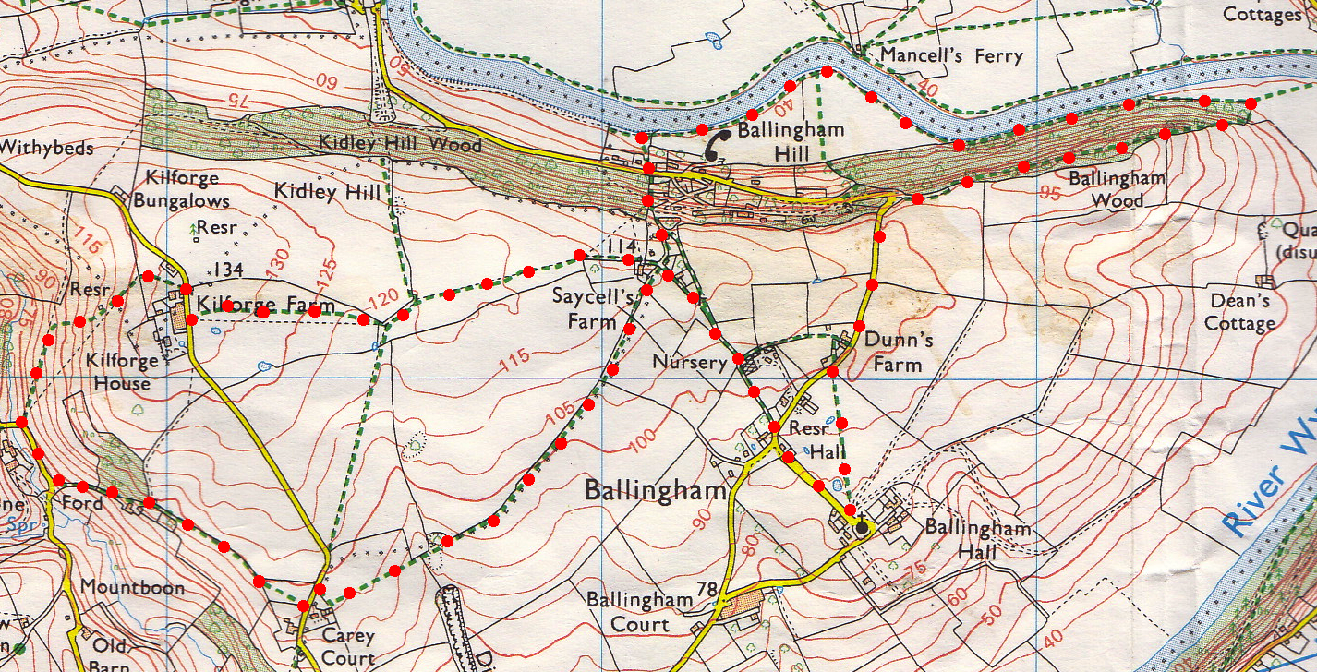

**6. Mansells Ferry.**  Now follow the river downstream and over a stile by a hut, to continue along the river bank and on thru the lower edge of Ballingham Wood. Cross over a stile into a field and walk along the R edge of the field to where the trees end. TR, after 25 paces TR again and go thru a metal gate into the Woods. Walk up 25 wooden steps and along an enclosed track that runs along the inside upper L hand edge of the wood. Near the end of the wood you go thru a metal gate, and bear R to continue along a tarmac track to reach a hairpin bend in the road. TL, continue up the road to Ballingham Council Notice Board where you TL and go back to the car.

**5**

**4**

**3**

**2**

**1**